Math Homework Week 2.1 Name:________________________ #____
Students MUST show ALL of their work. Please staple work pages to this page before turning in.
Students get to choose one out of the four:
- If you don’t complete a challenge, you must complete all problems on worksheet.
- Choose one challenge math problems and complete 12 problems on worksheet
- Choose two challenge math and complete 10 problems on worksheet
- Choose three challenge math and complete 8 problems on worksheet

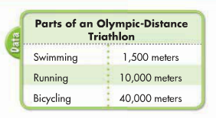
- What is the total distance traveled in one triathlon?

51,500 meters

- Susan has completed 10 triathlons. How far did she bicycle in the races?
400,000 meters
- For every 30 minutes of television air time, about 8 of the minutes are given to TV commercials. If 90 minutes of television is aired, how many minutes of commercials will be played? How many minutes of the show will be played?
Commercials: 24 minutes, Show time: 66 minutes

Problems 4-11 Estimating Products –
Remember:
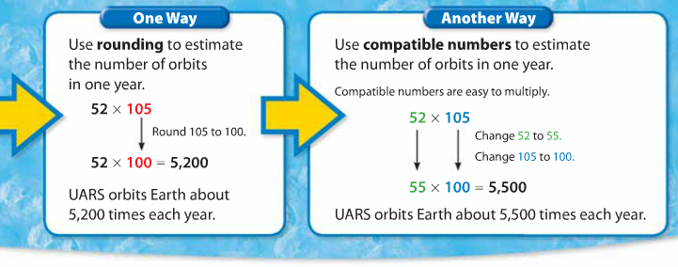
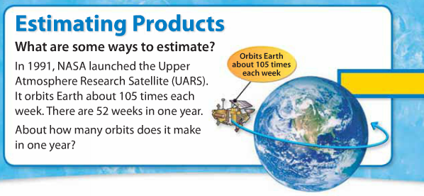

4. 32 x 83 = 2,400
5. 64 x 85 = 5,400
6. 31 x 46 = 1,500
7. 42 x 703 = 28,000
8. 346 x 18 = 7,000
9. 79 x 43 = 3,200
10. 324 x 45 = 16,000
11. 96 x 37 = 370 or 400

12. A roller coaster runs rides 50 times an hour and reaches speeds of 70 miles per hour. If each ride takes 8 rows of 4 people, how many people ride each hour?
1600 people
13. How many fossil kits with 12 samples each have the same number of fossils as 30 kits with 8 samples each?
20 kits
14. In the United States, students spend about 900 hours per year in school. How many hours would a student spend in 12 years of school?
10,800 hours
15. Jon’s backyard is a rectangle that measures 32 feet by 44 feet. How many square feet is his backyard?
1,408 square feet
16. Mr. Morris bought a sketchpad for 24 of his students. Each pad contained 58 sheets. How many sheets of paper were there altogether?
1,392 sheets
17. Julia used 3 rolls of film to take pictures on her vacation. There were 24 pictures on each roll. How many pictures did Julia take? It cost Julia 12 cents to print each picture. How much would it cost Julia to print every picture?
72 pictures, 864 cents ($8.64)
18. Dave plans to retile his porch floor. He wants to buy 38 black tiles and 27 white tiles. The black tiles cost $3 and the white tiles cost $4. How much money will he spend?
$222

