Name: _________________________________ Homework Week 1.8
Students have choice this week in their homework; choose ONE out of the four:
- If you don’t complete a challenge, you must complete all problems on worksheet.
- Choose one challenge math problems and complete 8 problems on worksheet
- Choose two challenge math and complete 5 problems on worksheet
- Choose three challenge math and complete 2 problems on worksheet
Use the following chart for questions 1-3

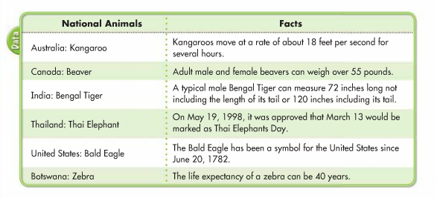
- How long can the tail of a male Bengal Tiger be?
48 inches

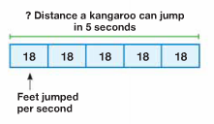
- How far can a kangaroo travel in 5 seconds?
90 feet

- The largest of all zebras is the Grevy’s zebra. A male Grevy’s zebra, on average, weighs 431 kilograms. The average female Grevy’s zebra weighs 386 kilograms. How much more does a male Grevy’s zebra weigh than a female Grevy’s zebra?
45 kilograms

Solve:
- 8 x 3 = (4 x 3) + (4 x ____) = ?
3

- 3 x 13 = (3 + ___) = (3 x ___) + (3 x 3) = ____
36, 10, 39

- Give an example of each property:
  - Commutative Property of Addition:
1+2=2+1
  - Commutative Property of Multiplication:
1x2=2x1
  - Associative Property of Addition:
1+(2+3)=(1+2)+3
  - Associative Property of Multiplication:
1x(2x3)=(1x2)x3

- Why isn’t there a Commutative or Associative Property of Subtraction or Division? Explain your answer: See teacher
________________________________________________________________________________
________________________________________________________________________________
________________________________________________________________________________
________________________________________________________________________________

- Frank wrote 3 x 6 to describe the total number of paper clips shown. Alexa wrote 6 x 3. Who is correct? Explain. See Teacher
________________________________________________________________________________
________________________________________________________________________________
________________________________________________________________________________
________________________________________________________________________________

- 34 x 56 = 1904

- 87 x 76 = 6612

- 176 x 7=1232

- 598 x 8= 4784

- 89 x 46=4094

- 762 x 9= 6858

Challenge Questions: Posted in classroom

