Name: _________________________________ Homework Week 1.8
Students have choice this week in their homework; choose ONE out of the four:
- If you don’t complete a challenge, you must complete all problems on worksheet.
- Choose one challenge math problems and complete 8 problems on worksheet
- Choose two challenge math and complete 5 problems on worksheet
- Choose three challenge math and complete 2 problems on worksheet
Use the following chart for questions 1-3

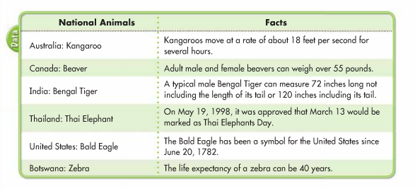
- How long can the tail of a male Bengal Tiger be?

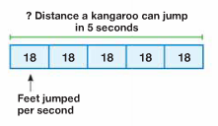
- How far can a kangaroo travel in 5 seconds?

- The largest of all zebras is the Grevy’s zebra. A male Grevy’s zebra, on average, weighs 431 kilograms. The average female Grevy’s zebra weighs 386 kilograms. How much more does a male Grevy’s zebra weigh than a female Grevy’s zebra?

Solve:
- 8 x 3 = (4 x 3) + (4 x ____) = ?

- 3 x 13 = (3 + ___) = (3 x ___) + (3 x 3_ = ____

- Give an example of each property:
  - Commutative Property of Addition:

  - Commutative Property of Multiplication:

  - Associative Property of Addition:

  - Associative Property of Multiplication:

- Why isn’t there a Commutative or Associative Property of Subtraction or Division? Explain your answer:
________________________________________________________________________________
________________________________________________________________________________
________________________________________________________________________________
________________________________________________________________________________

- Frank wrote 3 x 6 to describe the total number of paper clips shown. Alexa wrote 6 x 3. Who is correct? Explain.
________________________________________________________________________________
________________________________________________________________________________
________________________________________________________________________________
________________________________________________________________________________

- 34 x 56

- 87 x 76

- 176 x 7

- 598 x 8

- 89 x 46

- 762 x 9

Challenge Questions:

