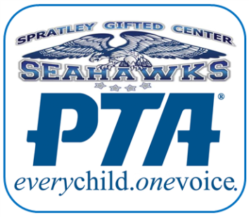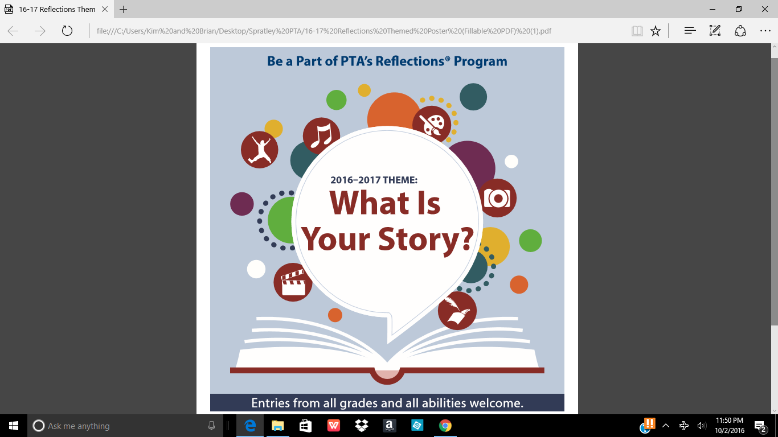

**The PTA Reflections program is a chance to recognize students for their creativity in the arts. Students submit theme-based original artwork in one of several categories: Dance choreography, film production, literature, musical composition, photography or visual arts (everything from drawings, paintings and collages to ceramics, jewelry and architecture.) There is also a special artist category for students with disabilities. Top national winners can earn scholarships as well as have their work displayed in a traveling art exhibit.**

**For more information on each category, visit www.vapta.org/arts-and-education/reflections. There are specific rules and size guidelines for each category – please pay close attention! Each entry *must* be accompanied by a student statement and entry form.**

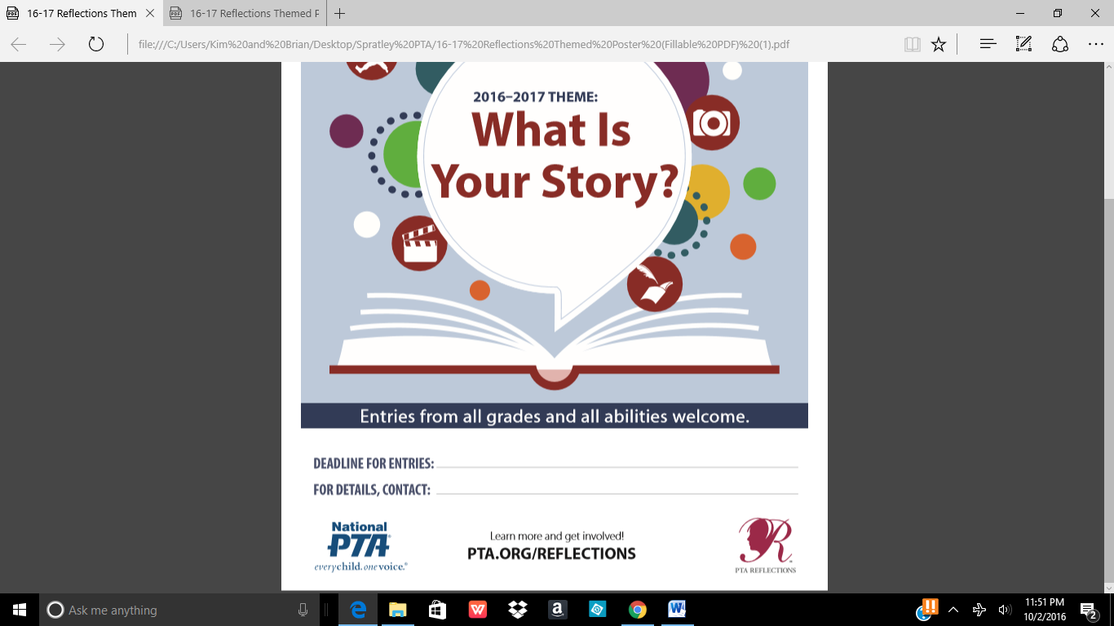

**Oct. 28, 2016**

**Kim Root, 757-218-9154 or kimberoot@gmail.com**